**CHAPTER 6**

**SCREEN SHOTS**

The below given fig 6.1 show the homepage of Online Room Booking System. The page shown to any user who opens the website the first time and it gives brief description about the website. It contains About section. The photos of Rooms which are offered by the website can be seen in Gallery section.

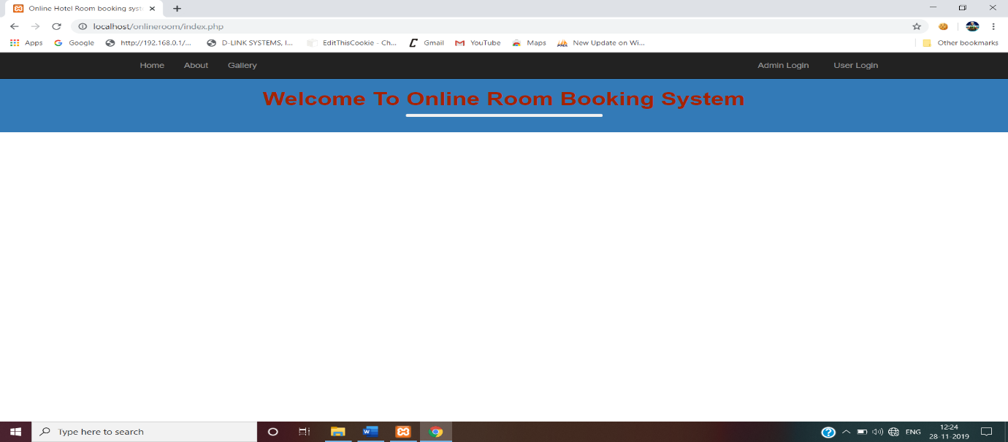

***Fig 6.1:*** *Welcome Screen*

The fig 6.2 is the registration page where the user registers to the website to view their profile. User have to provide Name, Email-Id, Password, Mobile Number, Address, Gender and Country. After submitting the details, user can view their profile.

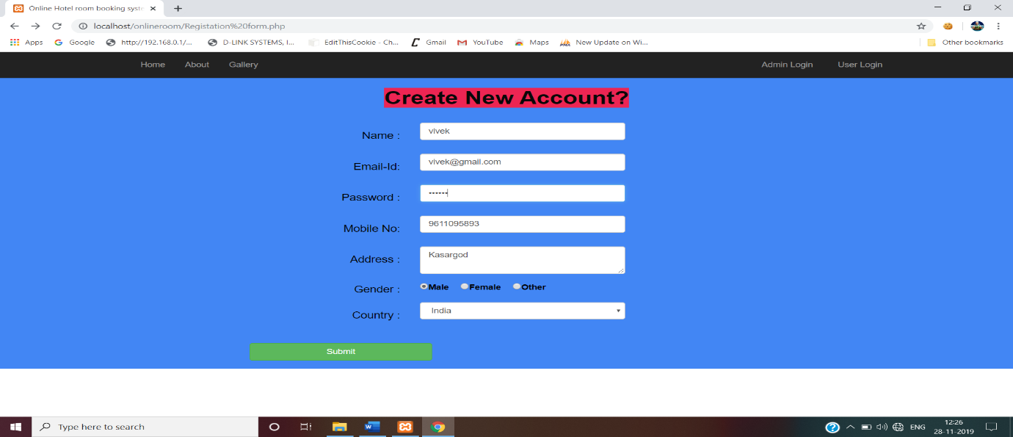

***Fig 6.2:*** *Registration screen*

The fig 6.3 is the Room Booking form where the registered users can select the room type to book room. User have to provide Name, Email, Mobile Number, Address, Country, Room type, Check in date, Check in Time, Check out Date, Occupancy. After submitting the details, a notification will say that room is booked.

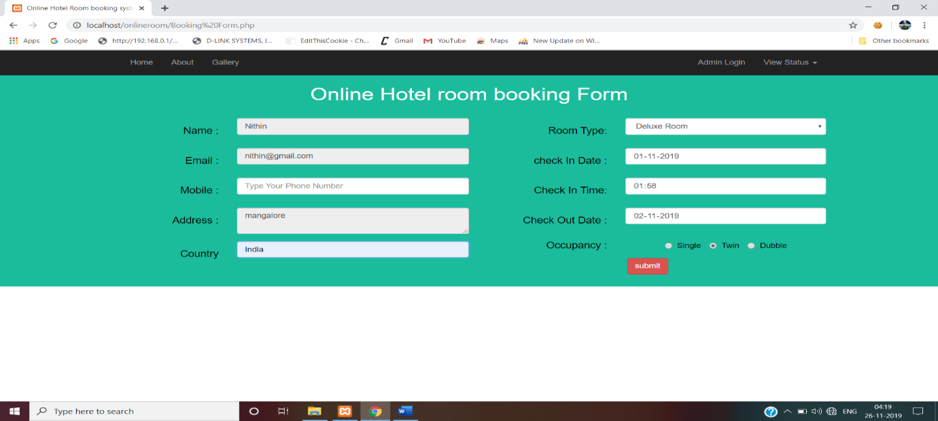

***Fig 6.3:*** *Room Booking form*

Fig 6.4 is the page admin can view the booking details which are booked by the users, which provides details about the user Name, Email, Mobile Number, Address, Room type, Check in date, Check in time, Check out date, Occupancy.

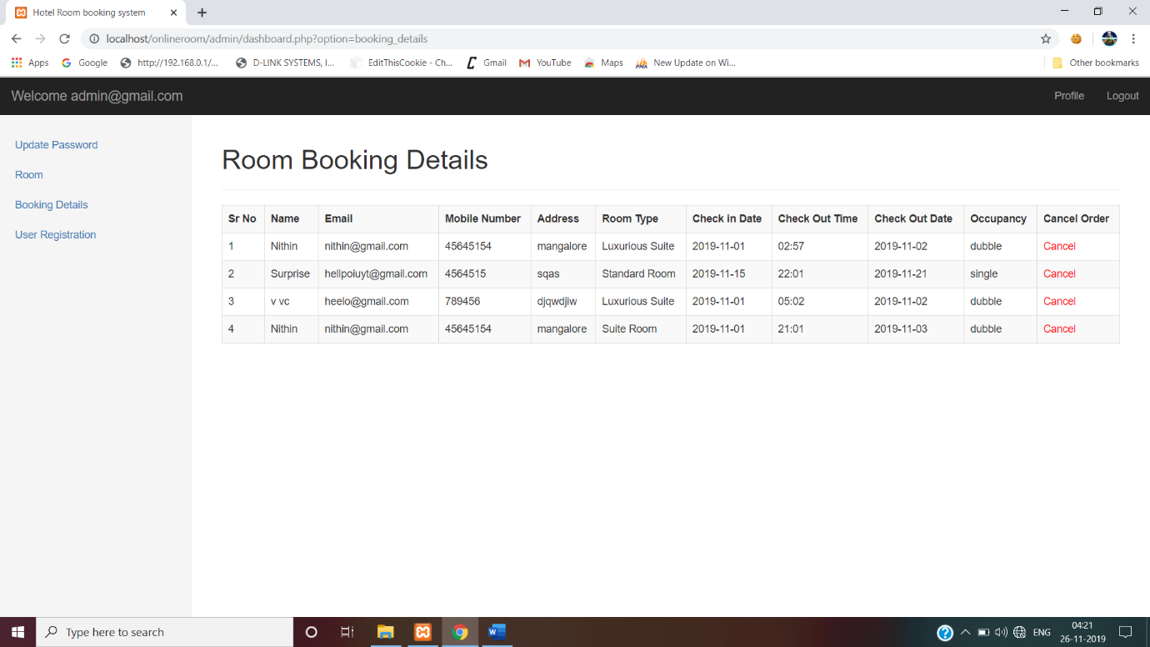

***Fig 6.4:*** *Room Booked details by users*

The fig 6.5 is the admin page where the admin can manage the website. Admin can view the profile, Update the password, add rooms, see users who are registered.

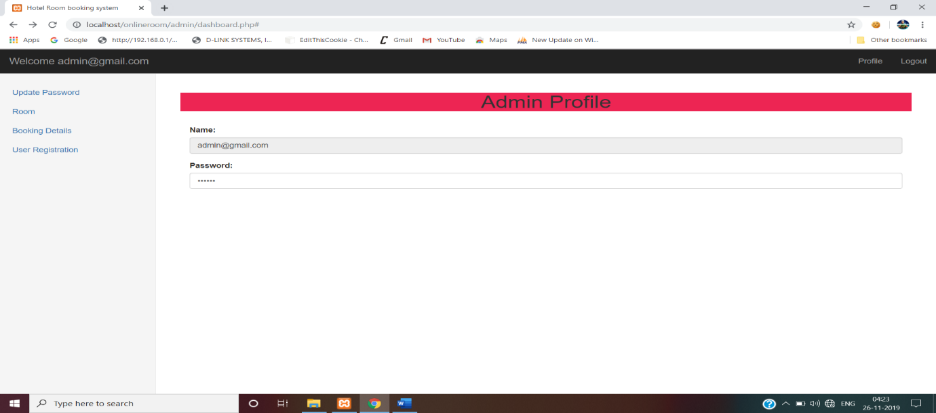

***Fig 6.5:*** *Admin page*

The fig 6.6 is the page which is used by the admin to add new rooms to the website for which users can book. It contains the Image of a room, Room number, Room type, Price, A brief details about the Room.

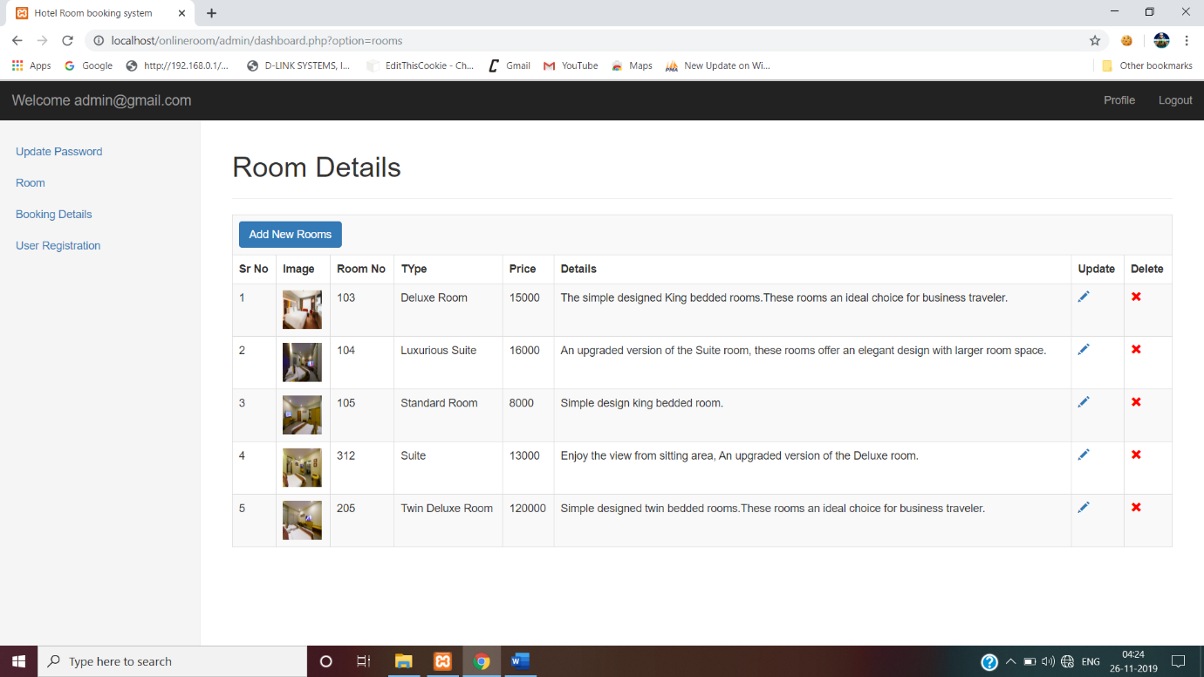

***Fig 6.6:*** *Add Room page*

The fig 6.7 is the user details page which is managed by the admin who can delete the users who have registered to the website. It contains User Name, Email-Id, Mobile Number, Address, Gender and country.

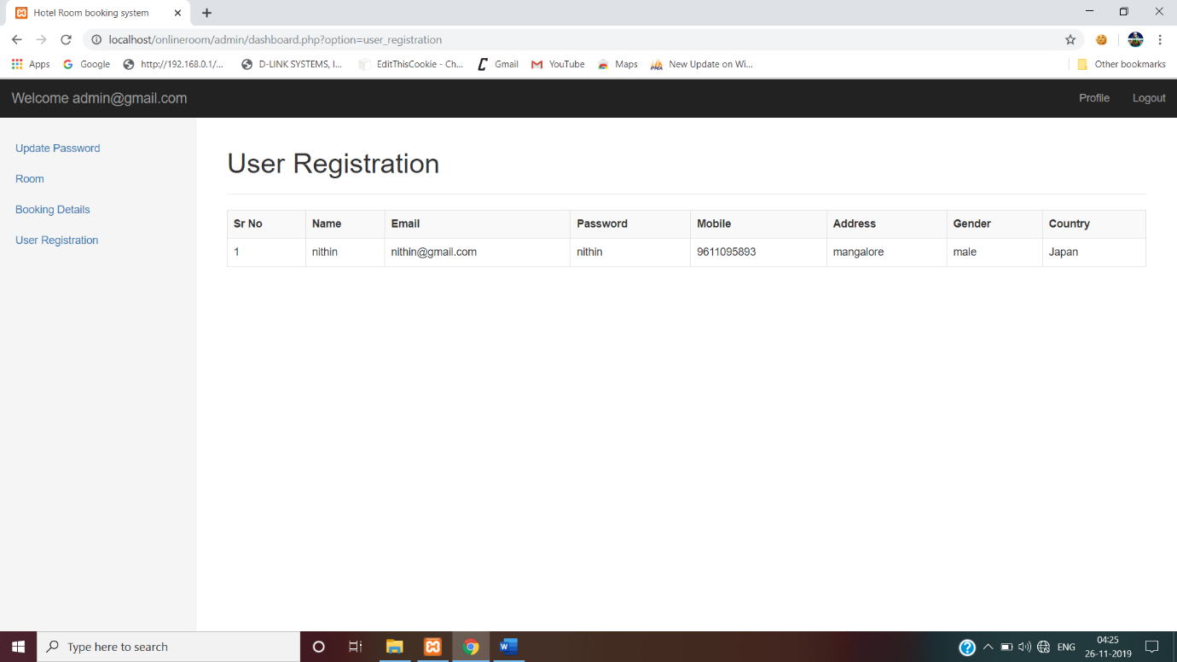

***Fig 6.7:*** *User details*

The fig 6.8 is the Booked Room Status page which is viewed by the users who have booked a room in the website. It contains User Name, Email-Id, Mobile number, Room Type, Check in date, check in date, check out date, Occupancy and Cancel Button to cancel the booking.

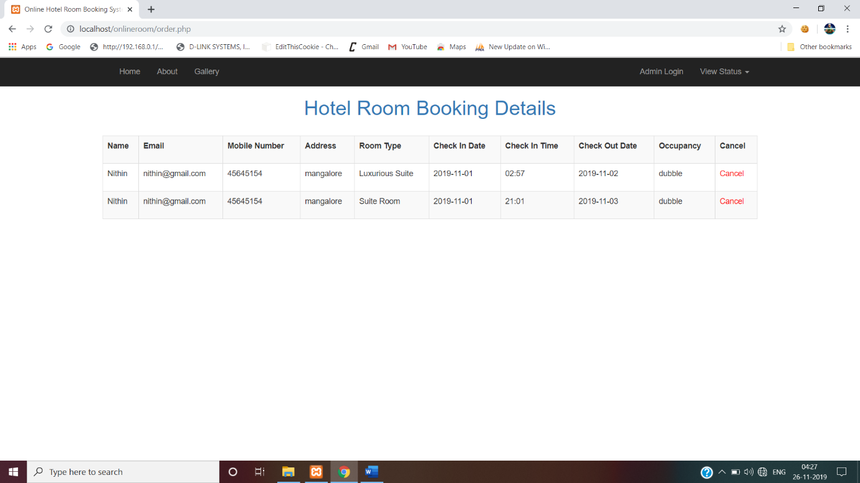

***Fig 6.8:*** *Booking Status Page*